Recommended reading for Year 7 during the Summer break

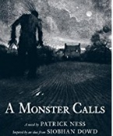 | A Monster Calls (Illustrated version) | Patrick Ness | Winner of the Carnegie and Greenaway Medals 2012. The illustrated version brings an extra depth to the story.
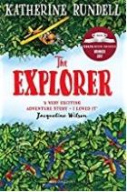 | The Explorer | Katherine Rundell | Winner of the Costa Award 2017. An exciting adventure story.
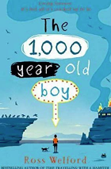 | The 1000-Year Old Boy | Ross Welford | A story about a boy who accidentally never dies and can remember the Viking invasion of England. A story about love and friendship and survival.
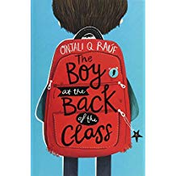 | The Boy at the Back of the Class | Onjali Rauf | Winner of the Blue Peter and Waterstones Book Prizes. A book about what it means to be a refugee.
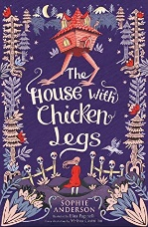 | The House with Chicken Legs | Sophie Anderson | Shortlisted for many book awards. This book is based on the Russian myth of Baba Yaga, and is a wonderful retelling of the story.
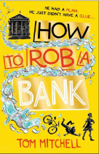 | How to Rob a Bank | Tom Mitchell | A very funny book about the adventures of hapless Dylan who only wants to impress his new girlfriend.
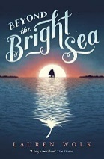 | Beyond the Bright Sea | Lauren Wolk | A story set on a remote island, starkly beautiful. Crow was washed up on the island as a baby, and now she needs to find out who she is.
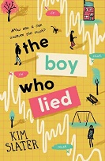 | The boy Who Lied | Kim Slater | A cautionary tale about lies, friendship and the need to be trustworthy.
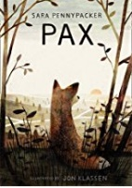 | Pax | Sara Pennypacker | Chosen by the Book Trust to send out to all schools, this book tells of the trust between a boy and his pet fox, which he has to let go into the wild.
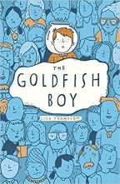 | Goldfish Boy | Lisa Thompson | Trapped in his bedroom with crippling OCD, Matthew witnesses the disappearance of a child. Can he overcome his terrors to help solve this mystery?
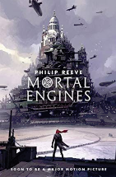 | Mortal Engines | Philip Reeve | Although this first book in the award winning trilogy was published some time ago, it’s had a new lease of life due to the film of the story. A great dystopian fantasy.
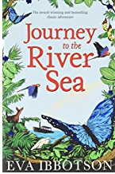 | Journey to the River Sea | Eva Ibbotson | Smarties Gold Prize winner. This is an adventure story with the Amazon as its backdrop.
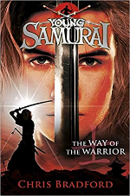 | The Way of the Warrior (Young Samurai, book 1) | Chris Bradford | An amazing adventure story, set in ancient Japan. Jack Fletcher is the only survivor of a shipwreck and finds himself battling ninja pirates and other enemies.
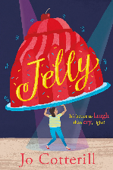 | Jelly | Jo Cotterill | Angelica (nicknamed Jelly) uses humour to deflect nasty comments and cruel jibes. How does she discover the courage to face up to her insecurities?
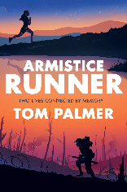 | Armistice Runner | Tom Palmer | A keen fell-runner, Lily finds her great-great-grandfather's diaries whilst visiting her Gran who has Alzheimer’s. She becomes fascinated by her ancestor who shares her love of running and uses his skills on the battlefields of World War 1!

